# MongoDB Lab – Day 3 (CRUD Operations) by SK NAHID FAIYAZ

## Q1. Display all student records from the collection.

db.students.find()

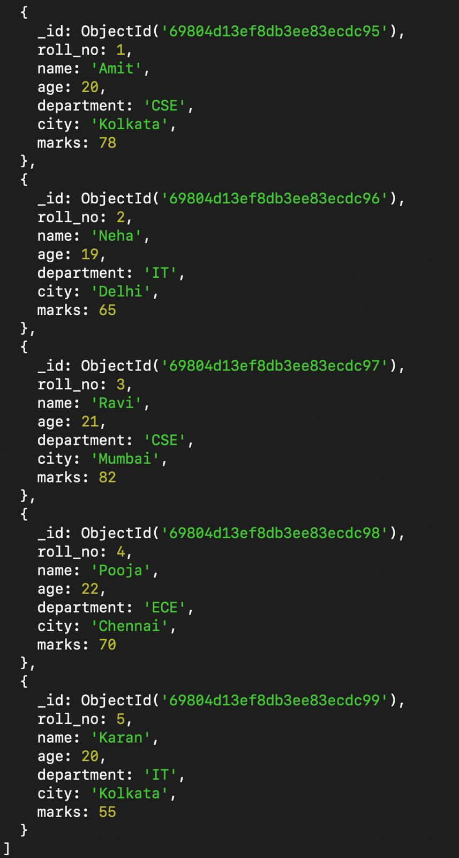

## Q2. Display only the name and department of all students.

db.students.find({}, { _id: 0, name: 1, department: 1 })

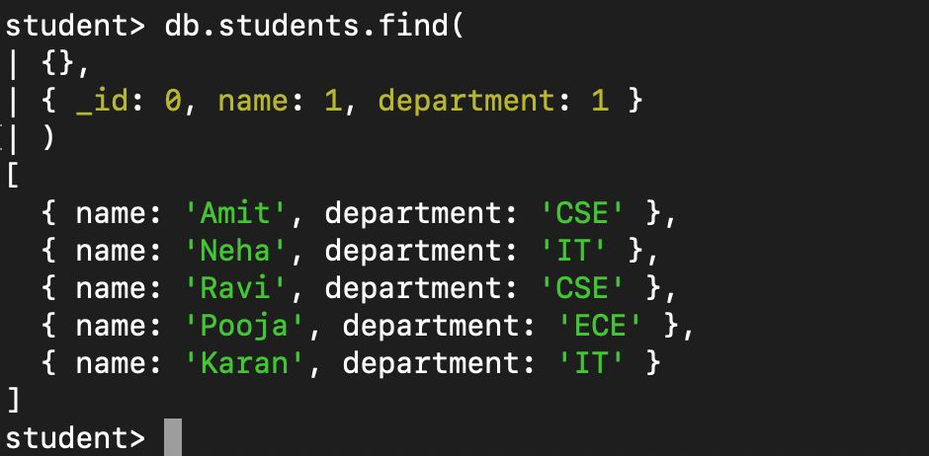

## Q3. Find students belonging to the CSE department.

db.students.find({ department: 'CSE' })

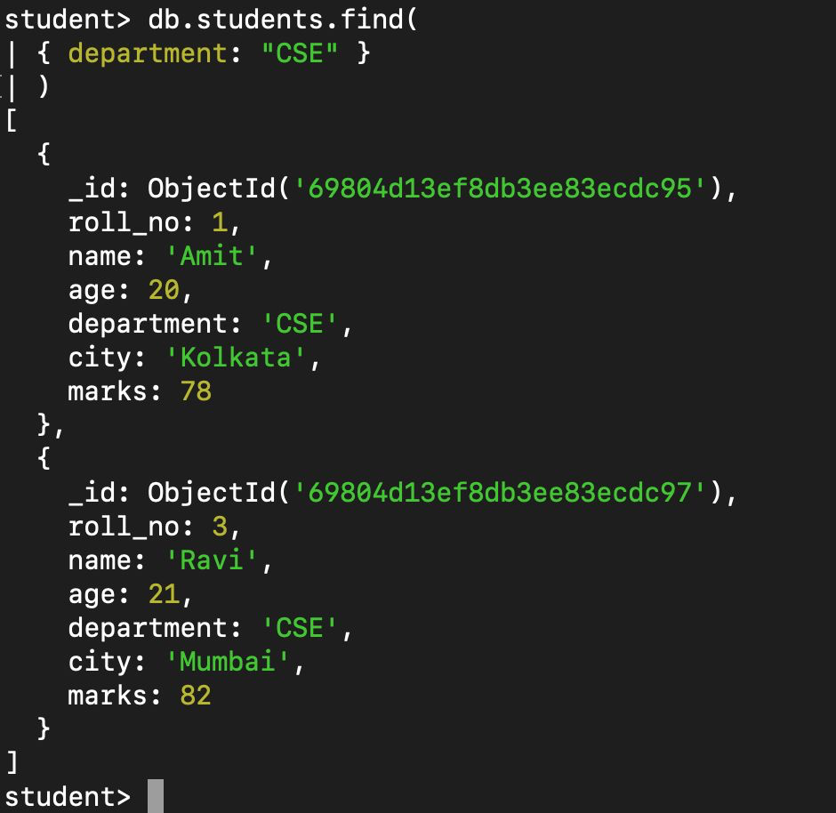

## Q4. Find students whose age is greater than 20.

db.students.find({ age: { $gt: 20 } })

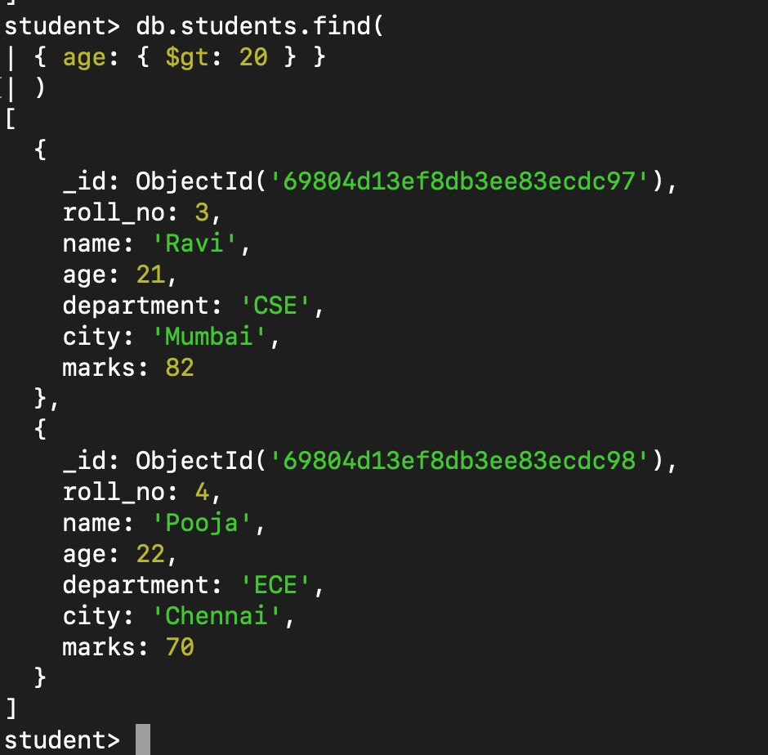

## Q5. Find students who scored less than 70 marks.

db.students.find({ marks: { $lt: 70 } })

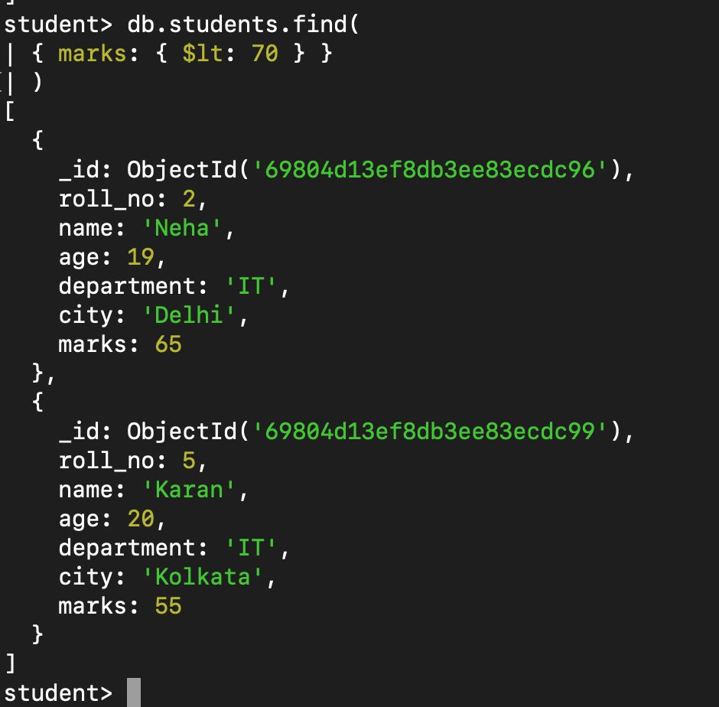

## Q6. Display students belonging to Kolkata city.

db.students.find({ city: 'Kolkata' })

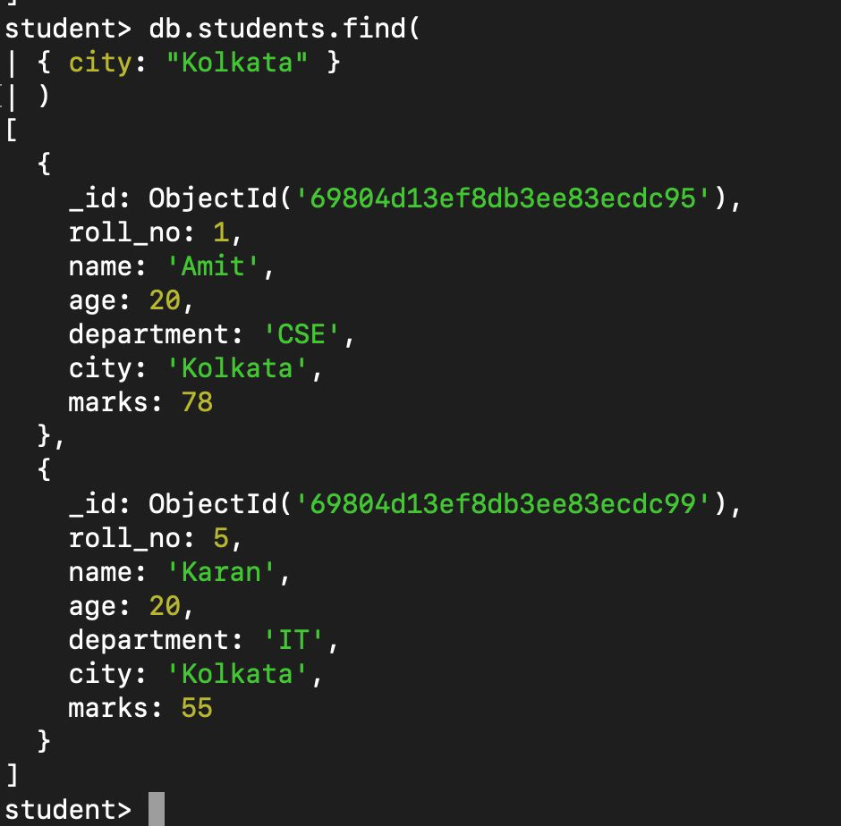

## Q7. Sort students by age in ascending order.

db.students.find().sort({ age: 1 })

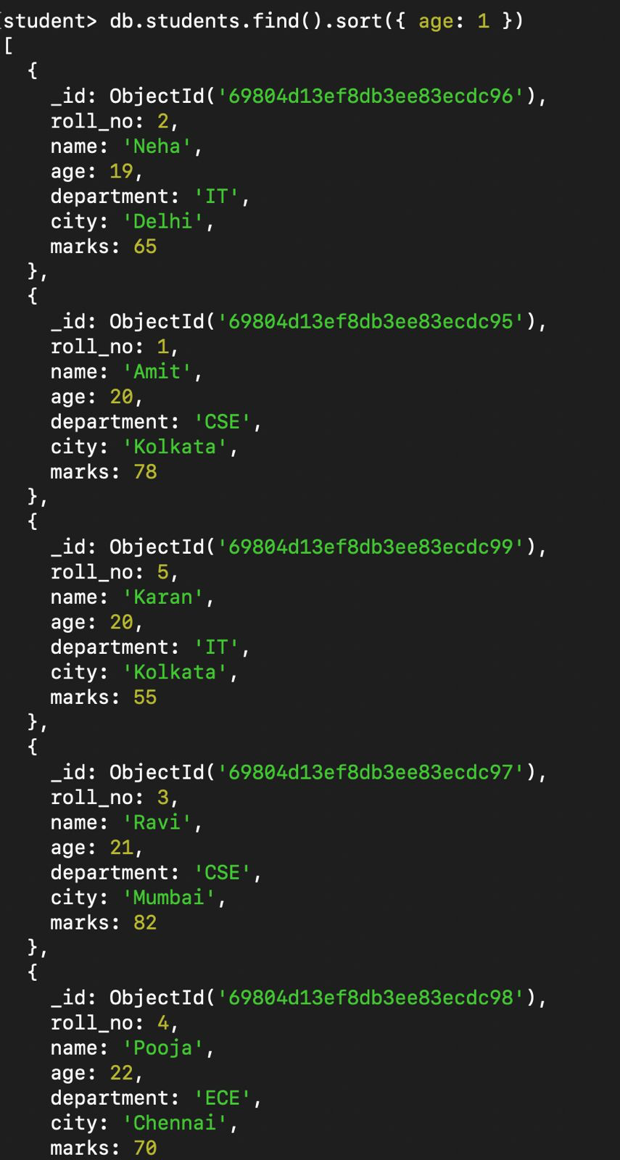

## Q8. Sort students by marks in descending order.

db.students.find().sort({ marks: -1 })

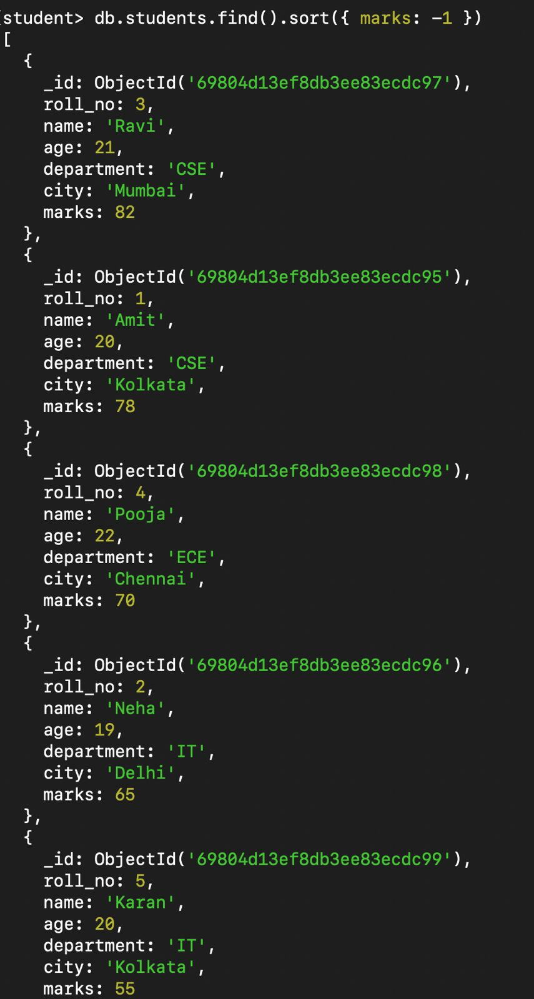

## Q9. Display only the first three student records.

db.students.find().limit(3)

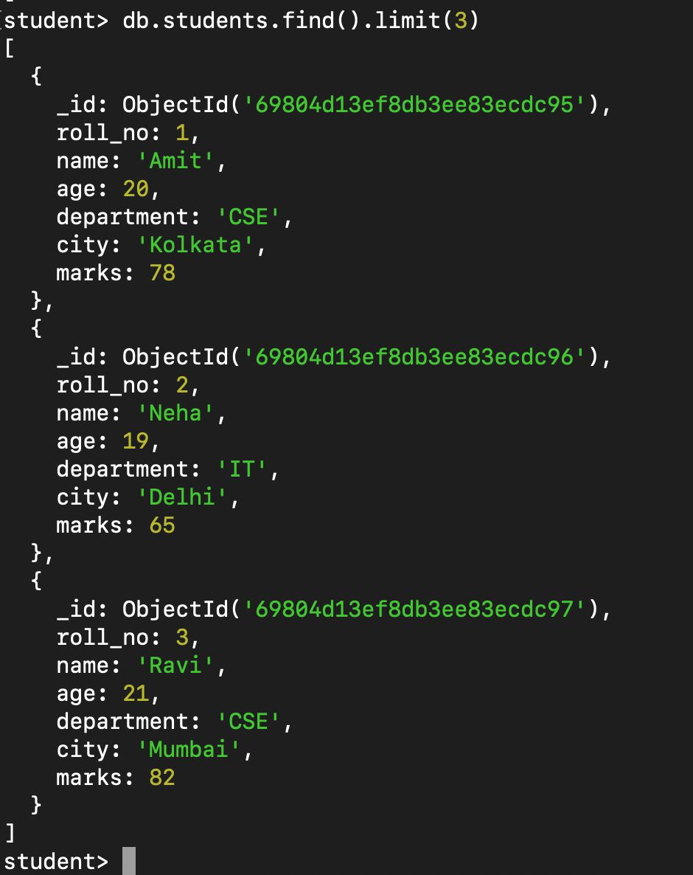

## Q10. Update the marks of student Neha to 72.

db.students.updateOne({ name: 'Neha' }, { $set: { marks: 72 } })

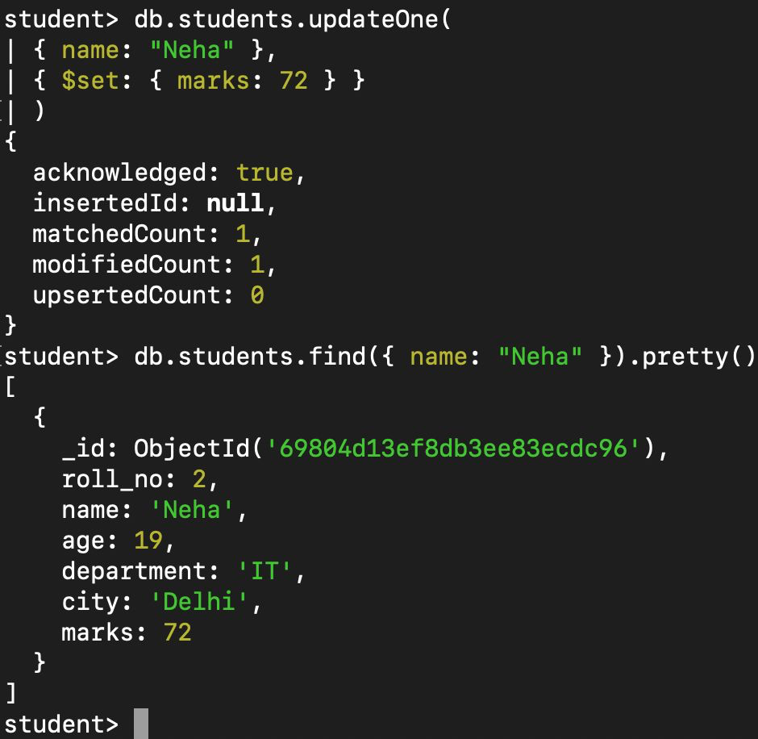

## Q11. Increase the marks of all students by 5.

db.students.updateMany({}, { $inc: { marks: 5 } })

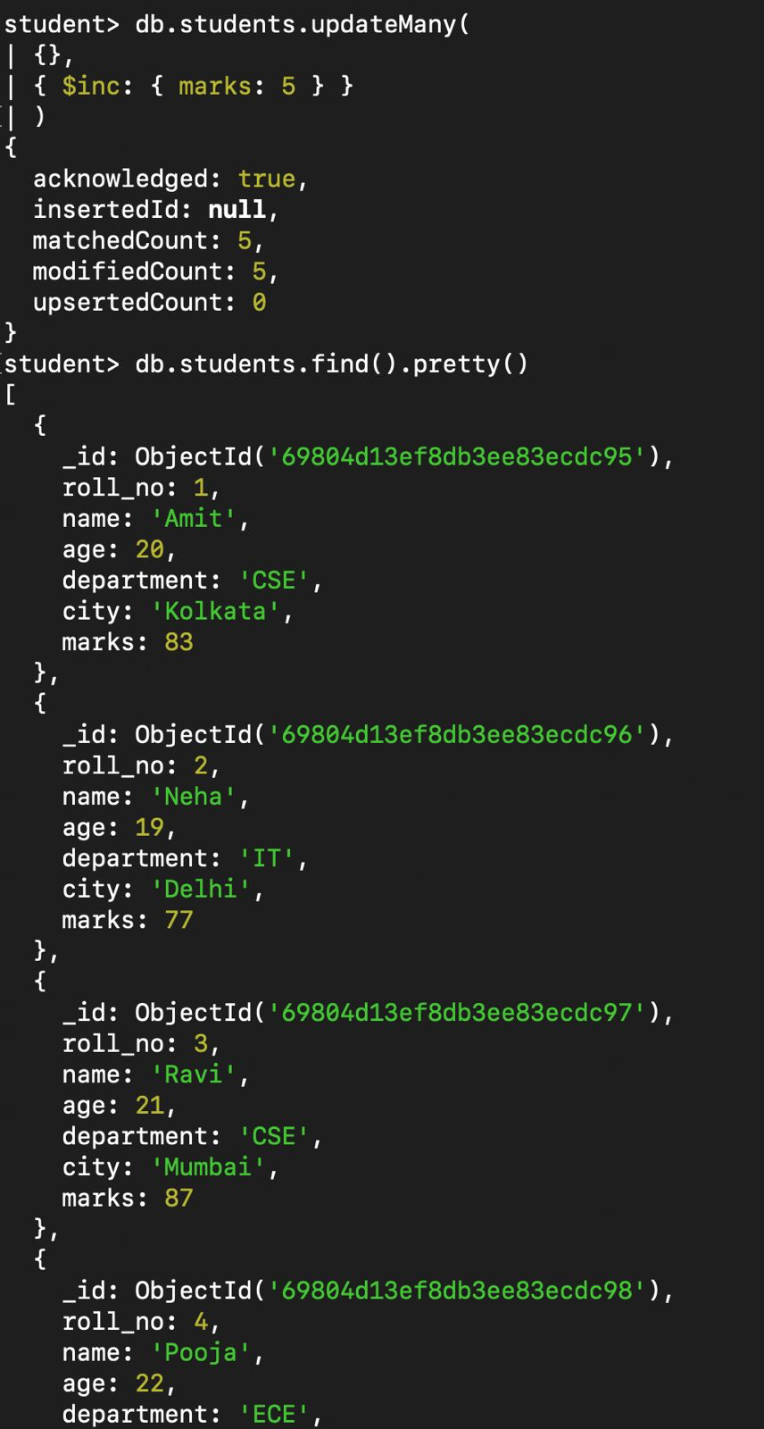

## Q12. Delete the student having roll number 5.

db.students.deleteOne({ roll_no: 5 })

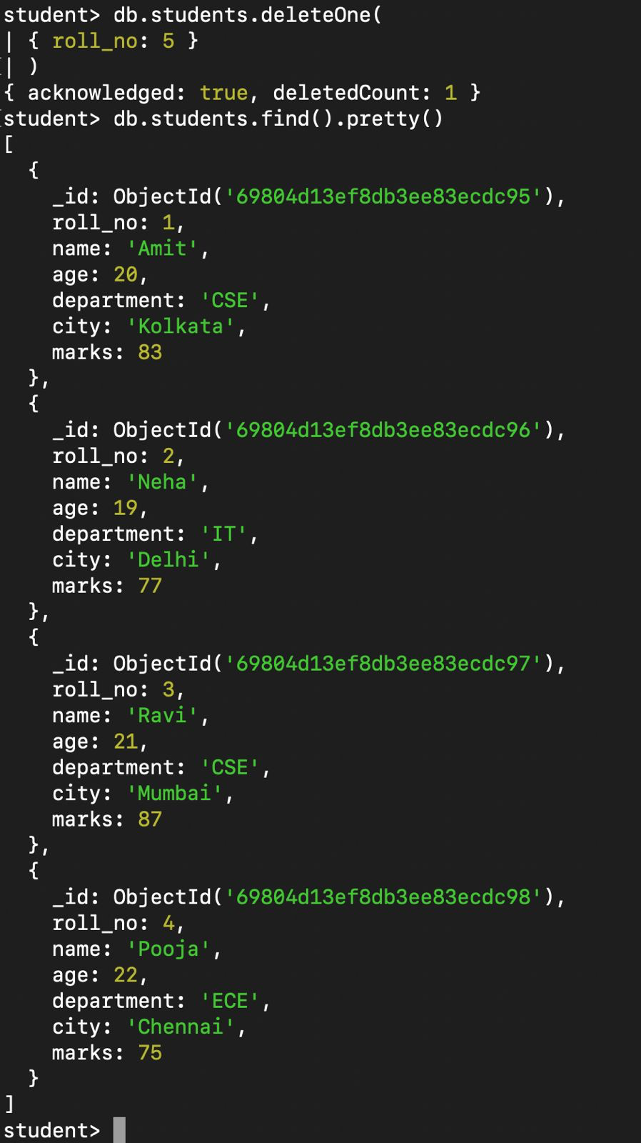

## Q13. Find students whose age is between 20 and 22.

db.students.find({ age: { $gte: 20, $lte: 22 } })

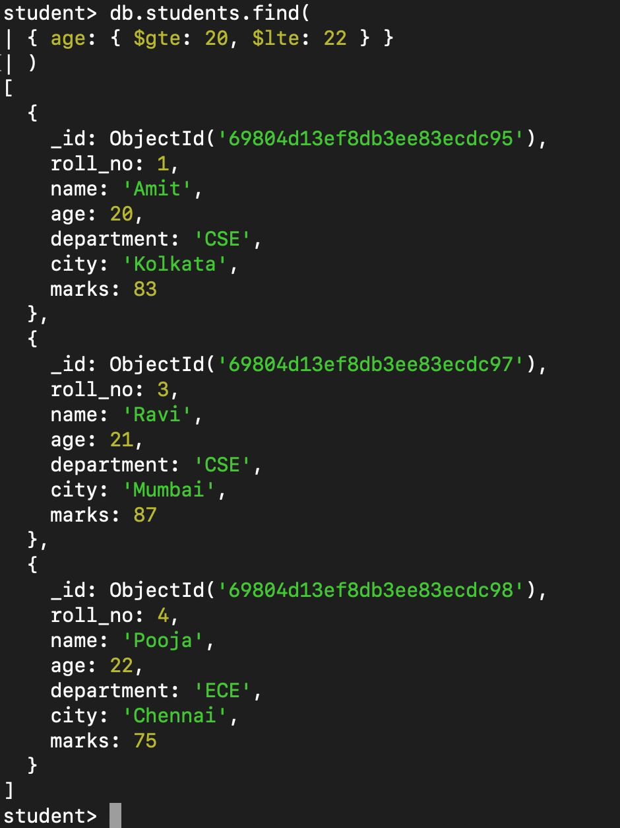

## Q14. Display students belonging to either CSE or IT department.

db.students.find({ department: { $in: ['CSE', 'IT'] } })

